# Grove - Infrared Emitter

|  |
| --- |
| Contents  [[hide](javascript:toggleToc())]   * [1 Introduction](http://www.seeedstudio.com/wiki/Grove_-_Infrared_Emitter#Introduction) * [2 Features](http://www.seeedstudio.com/wiki/Grove_-_Infrared_Emitter#Features) * [3 Application Ideas](http://www.seeedstudio.com/wiki/Grove_-_Infrared_Emitter#Application_Ideas) * [4 Mechanic Dimensions](http://www.seeedstudio.com/wiki/Grove_-_Infrared_Emitter#Mechanic_Dimensions) * [5 Usage](http://www.seeedstudio.com/wiki/Grove_-_Infrared_Emitter#Usage)   + [5.1 Hardware Installation](http://www.seeedstudio.com/wiki/Grove_-_Infrared_Emitter#Hardware_Installation)   + [5.2 Programming](http://www.seeedstudio.com/wiki/Grove_-_Infrared_Emitter#Programming) * [6 Support](http://www.seeedstudio.com/wiki/Grove_-_Infrared_Emitter#Support) * [7 Version Tracker](http://www.seeedstudio.com/wiki/Grove_-_Infrared_Emitter#Version_Tracker) * [8 Resources](http://www.seeedstudio.com/wiki/Grove_-_Infrared_Emitter#Resources) * [9 How to buy](http://www.seeedstudio.com/wiki/Grove_-_Infrared_Emitter#How_to_buy) * [10 See Also](http://www.seeedstudio.com/wiki/Grove_-_Infrared_Emitter#See_Also) * [11 Licensing](http://www.seeedstudio.com/wiki/Grove_-_Infrared_Emitter#Licensing) |

## Introduction

The Infrared Emitter is used to transmit infrared signals through an infrared LED, while there is an [Infrared receiver](http://www.seeedstudio.com/wiki/Grove_-_Infrared_Receiver) to get the signals on the other side . An infrared LED is like any other LED, with its color centered around 940nm. We can use the emitter not only to transmit data or commands, but also to emulate remotes to control your home appliance using an Arduino. The Infrared Emitter can transmit signals reliable up to 10 meters. Beyond 10 meters, the receiver may not get the signals.

**Model:**[**WLS12148P**](http://www.seeedstudio.com/depot/grove-infrared-emitter-p-993.html?cPath=139_204)

[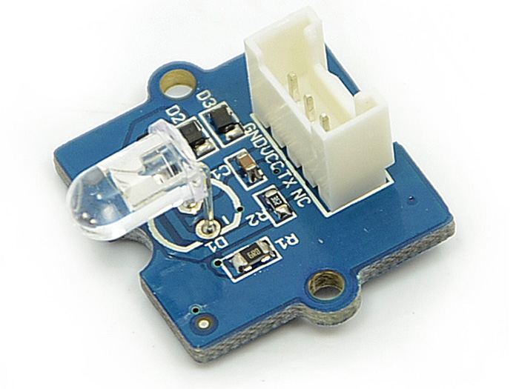](http://www.seeedstudio.com/wiki/File:Grove_-_Infrared_Emitter.jpg)

## Features

* Grove compatible interface
* 940nm IR LED

## Application Ideas

* Remote control

## Mechanic Dimensions

20mm by 24mm. The IR LED extends by another 7.5mm beyond the PCB.

## Usage

The IRremote library used in the example below relies on using Pin 3 of the arduino for PWM output.

For non-IRremote based usage of this Grove, other pins could be used.

### Hardware Installation

Connect the Transmitter module to Digital I/O 2 of the [Grove - Base Shield](http://www.seeedstudio.com/wiki/Grove_-_Base_Shield) on the receiving arduino.

### Programming

The demo below is the IRsendDemo.pde example provided by the IRremote library.

Download [IRremote.zip](http://arcfn.com/files/IRremote.zip) and unpack into arduino/hardware/libraries in your arduino installation.

/*

* IRremote: IRsendDemo - demonstrates sending IR codes with IRsend

* An IR LED must be connected to Arduino PWM pin 3.

* Version 0.1 July, 2009

* Copyright 2009 Ken Shirriff

* http://arcfn.com

*/

#include <IRremote.h>

IRsend irsend;

**void** **setup**()

{

**Serial**.begin(9600);

}

**void** **loop**() {

**if** (**Serial**.read() != -1) {

**for** (**int** i = 0; i < 3; i++) {

irsend.sendSony(0xa90, 12); // Sony TV power code

delay(100);

}

delay(3*1000);

}

}

## Support

[Ask questions on Seeed forum](http://www.seeedstudio.com/forum).

## Version Tracker

|  |  |  |
| --- | --- | --- |
| **Revision** | **Descriptions** | **Release** |
| v0.9b | Initial public release | 04,Oct,2011 |

## Resources

* Eagle files: [File:Twig - Infrared Emitter v0.9b.zip](http://www.seeedstudio.com/wiki/File:Twig_-_Infrared_Emitter_v0.9b.zip)
* Schematic (PDF): [File:Twig - Infrared Emitter v0.9.pdf](http://www.seeedstudio.com/wiki/File:Twig_-_Infrared_Emitter_v0.9.pdf)
* [IRremote arduino library](http://arcfn.com/files/IRremote.zip)
* [IRremote arduino library documentation](http://www.arcfn.com/2009/08/multi-protocol-infrared-remote-library.html)
* [TSAL6200 Datasheet](http://www.vishay.com/docs/81010/tsal6200.pdf)